Research Career Options
目录
Occupational information 1
Job & Career Accelerator – Internships 1
Texas - Reality Check 2

Occupational information
- O*NET Online
The O*NET program is the nation's primary source of occupational information. Central to the project is the O*NET database, containing information on hundreds of standardized and occupation-specific descriptors.
- Occupational Outlook Handbook
The Occupational Outlook Handbook is a nationally recognized source of career information, designed to provide valuable assistance to individuals making decisions about their future work lives. The Handbook is revised every two years.

Job & Career Accelerator – Internships
You must create an account using your UT issued email address (utexas.edu).
- Select "Search for Jobs & Internships"
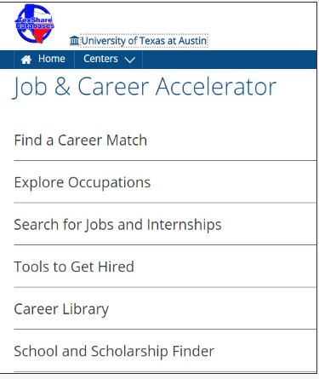
- Job & Career AcceleratorThis link opens in a new window
Unlimited users.
SEE ADDITIONAL INFO SECTION FOR REGISTRATION INFORMATION
Updated daily. Provides resources for job-seekers in all stages of the career exploration and job-application process. Users can assess their work-related interests, explore occupation profiles, search for jobs and internships, and get help preparing job-application materials.
This resource provides highly-personalized content, tracks training modules completed, and stores individualized resumes and cover letters.
Notes: accounts for LearningExpress Library and Job & Career Accelerator are interchangeable.

Texas - Reality Check
Brought to you by the Labor Market & Career Information Department of the Texas Workforce Commission
Texas Reality Check - Lifestyle Calculator
Will you be able to afford the lifestyle you want?
It's difficult to predict the future, but it's never too early to start planning for it. Texas Reality Check will show you how much your living expenses will cost, and the amount of money you will need to earn to pay for them.
Lifestyle Calculator
- Walk through expenses you'll incur each month
- Decide how much to spend on your lifestyle
- Determine your minimum salary needs
- Explore occupations that earn the salary you'll need
Occupation Calculator
- Choose an occupation, then review your expenses to see if its salary can support your lifestyle.
Quick View Calculator
- Skip the guided tour & quickly tally up your expenses to compare costs with different occupations.

https://texasrealitycheck.com/

